|  |
| --- |
| ST10274485, Tristyn Da Silva |
| POE Part 1 |
| WEDE5020 |

|  |
| --- |
|  |

Table of contents

Website choice: Wash It 2

Website Assets 3

Website Pages and Content 4

List of references 5, 6

Website Choice: Wash It

The choice that I have decided on is for a hypothetical local car wash in my area named Wash It. The main benefit that this local service can gain is notoriety about its services, time saving management, efficiency and the charging prices. The homepage would have the main logo along with its slogan and tabs directing where the consumer would like to go and inquire. The menus will have buttons that will jump to that dedicated heading for the consumer to find their needs and query. There will always be a help tab on the corner to always assist should the consumer have any troubles concerning the information, along with the respective contact information, regarding the website. The car cleaning and refreshing method will have a tab dedicated customizing layout for the consumer to choose the method they would want their car to be cleaned. Once the consumer has made their choice and selected the appropriate time slot available, the website will generate a unique strand codes as a ticket. Once the consumer has acquired their ticket, they may proceed to the car wash. There will be a tab for the location along with pictures of the car wash. The website font and style will be chosen that appear simple and legible to be read. The color of the website will have calm colors to represent the earnest and hardworking staff. There will be a special icon appearing on the method of cleaning the vehicles when there are discounts available. The consumer can make an account that can be notified if there are any discounts or promotional offers occurring at the carwash. This local car wash will gain popularity along with notoriety growth with the help of a website, since majority of consumers have access to the internet their various means. The target population will be aimed at those with cars since they would want a clean car to drive in. I would not only be helping my community by spreading the recognition this carwash deserves but I would be able to apply my skills to also be recognized for designing the website. In conclusion both parties involved receive benefits from this cooperation.

(363 words)

Website Assets

* Logo designed with Tailor Brands (Tailor Brands)
* 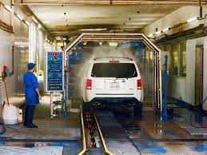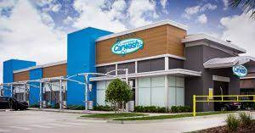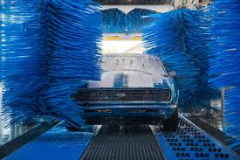Pictures of the carwash to be used:

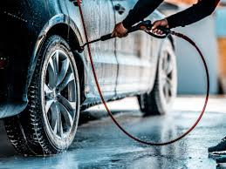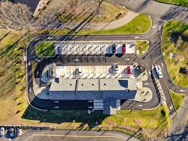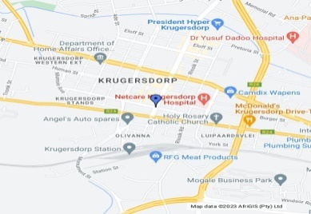

* Terms and services generator used for the website (Terms and services generator , 2022)
* Slogan for the carwash, “We clean, so that you don’t have to” (Chang)
* Carwash idea of services to be used on the website (Which Kind Of Car Wash Is Best For Your Finish, 2019)
* Terms and services template

Website Pages and Content

Homepage

1. Logo
2. Slogan
3. Links to other pages
4. Copyright with year

About Us

1. Logo
2. Pictures of the car wash
3. Picture of the location
4. Summary of business and details of services

Selection of services

1. Logo
2. Types of car washes

Contact us

1. Logo
2. Social media’s
3. Contact information and emails

Terms and policies

1. Document containing terms and policies

List of references

*Which Kind Of Car Wash Is Best For Your Finish*. (2019, February 16). Retrieved March 31, 2023, from diffterent types of car washes: https://www.drbeasleys.com/blog/2019/02/16/types-of-car-washes

*Terms and services generator* . (2022). Retrieved March 31, 2023, from Enzuzo: https://www.enzuzo.com/terms-of-service-generator?utm_term=terms%20of%20service%20policy%20generator&utm_campaign=42+-+Generic&utm_source=adwords&utm_medium=ppc&hsa_acc=7041263711&hsa_cam=17047973224&hsa_grp=137609529282&hsa_ad=594781877425&hsa_src=g&hsa_

Chang, L. (n.d.). *Mobile cusinie* . Retrieved March 31, 2023, from 175+ Unique Car Wash Solgans: https://mobile-cuisine.com/marketing/slogans/car-wash-slogans/

*Tailor Brands*. (n.d.). Retrieved March 22, 2023, from Tailor Brands: https://www.tailorbrands.com/lp-row-brand?utm_source=googlebrand&utm_medium=brand&utm_campaign=19805995428&utm_content=146932290877&utm_term=tailorbrands&gclid=CjwKCAjwzuqgBhAcEiwAdj5dRppXL6r9XTFVxpiG-bmrVg_stLiGD54MjQ0kYJCaBHhvGnA_D1bV9BoCPqgQAvD_BwE

Carwash - <https://www.google.com/imgres?imgurl=http%3A%2F%2Fsimiautospa.com%2Fwp-content%2Fuploads%2F2019%2F07%2FJEK_20190412_CDA_1140361-1024x768.jpg&tbnid=zZclarx9BbZQNM&vet=12ahUKEwifouD_uI3-AhXMmicCHeXjA74QMygPegUIARDoAQ..i&imgrefurl=http%3A%2F%2Fsimiautospa.com%2F&docid=IY2Tb0-N0PIsnM&w=1024&h=768&q=pictures%20of%20carwash%20facility&ved=2ahUKEwifouD_uI3-AhXMmicCHeXjA74QMygPegUIARDoAQ>

Carwash2 - <https://www.google.com/imgres?imgurl=https%3A%2F%2Fwww.schererconstruction.com%2Fwp-content%2Fuploads%2F2018%2F09%2Fcarwash-ftimg-300x157.jpg&tbnid=mPV1M6WLAC1JYM&vet=12ahUKEwifouD_uI3-AhXMmicCHeXjA74QMygFegUIARDSAQ..i&imgrefurl=https%3A%2F%2Fwww.schererconstruction.com%2Fnew-carwash-prototype-begins-in-jacksonville%2F&docid=90TArqdyRGXV_M&w=300&h=157&q=pictures%20of%20carwash%20facility&ved=2ahUKEwifouD_uI3-AhXMmicCHeXjA74QMygFegUIARDSAQ>

Carwash3 - <https://www.google.com/imgres?imgurl=https%3A%2F%2Fmcbeescnc.com%2Fwp-content%2Fuploads%2F2022%2F09%2Fcar-going-through-carwash-scaled.jpg&tbnid=ijsQ9sDXbXU2bM&vet=12ahUKEwifouD_uI3-AhXMmicCHeXjA74QMygjegUIARCcAg..i&imgrefurl=https%3A%2F%2Fmcbeescnc.com%2F&docid=0-T_eMljeY2dcM&w=2560&h=1707&q=pictures%20of%20carwash%20facility&ved=2ahUKEwifouD_uI3-AhXMmicCHeXjA74QMygjegUIARCcAg>

Carwash4 - <https://www.google.com/imgres?imgurl=https%3A%2F%2Fpatch.com%2Fimg%2Fcdn20%2Fgetty%2F25811147%2F20221031%2F033651%2Fstyles%2Fpatch_image%2Fpublic%2Fgettyimages-1310978724___31153540255.jpg&tbnid=_pAjIcWD-sfj9M&vet=12ahUKEwifouD_uI3-AhXMmicCHeXjA74QMyhRegUIARCMAQ..i&imgrefurl=https%3A%2F%2Fpatch.com%2Fnew-jersey%2Flongvalley%2Fnew-car-wash-facility-joins-long-valley-zoning-board-docket&docid=TDWalYvK9mmqAM&w=1065&h=799&q=pictures%20of%20carwash%20facility&ved=2ahUKEwifouD_uI3-AhXMmicCHeXjA74QMyhRegUIARCMAQ>

Carwash Top view - <https://www.google.com/imgres?imgurl=https%3A%2F%2Fimages.squarespace-cdn.com%2Fcontent%2Fv1%2F5964ffdd2cba5e4aab313259%2F1618340501445-RB6CVVKESJ1L1WWEH647%2FCar%2BWash%2BExpress2.jpg&tbnid=2vYcL2RdV5r0HM&vet=12ahUKEwifouD_uI3-AhXMmicCHeXjA74QMygnegUIARCkAg..i&imgrefurl=https%3A%2F%2Fwww.bartonandloguidice.com%2Fblog%2F2021%2F4%2F13%2Fautomated-tunnel-car-wash-facility&docid=PyI2O5Q_UpvOvM&w=2500&h=1875&q=pictures%20of%20carwash%20facility&ved=2ahUKEwifouD_uI3-AhXMmicCHeXjA74QMygnegUIARCkAg>

Carwash location - <https://www.google.com/mymaps/viewer?mid=1Yy7hrg61sFsYqyh9K91ShJRGV2Y&hl=en_US>

Carwash Icon- <https://www.google.com/url?sa=i&url=https%3A%2F%2Fwww.flaticon.com%2Ffree-icon%2Fcar-wash-machine_20973&psig=AOvVaw2OtQgLzisRteQplmzBbhWT&ust=1680616223643000&source=images&cd=vfe&ved=0CA8QjRxqFwoTCNjpjrDMjP4CFQAAAAAdAAAAABAE>

Term and services template - <https://privacyterms.io/terms-and-conditions-template/>